**SQL COMMANDS AND DATA TYPE**

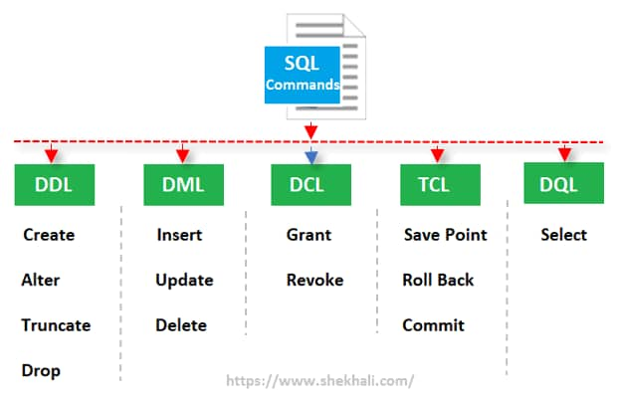

DDL stands for **Data Definition Language**. DDL changes the structure of the table like creating a table, deleting a table, altering a table, etc.

DML stands for **Data Manipulation Language**. DML commands are used to modify the database. It is responsible for all form of changes in the database.

DCL stands for **Data Control Language**. DCL commands are used to grant and take back authority from any database user.

TCL stands for **Transaction Control Language**. TCL commands can only use with DML commands like INSERT, DELETE and UPDATE only. These operations are automatically committed in the database that's why they cannot be used while creating tables or dropping them.

DQL stands for **Data Query Language.** DQL is used to fetch the data from the database.

**SQL Data Types**

The data type of a column defines what value the column can hold: integer, character, money, date and time, binary, and so on.

Each column in a database table is required to have a name and a data type. An SQL developer must decide what type of data that will be stored inside each column when creating a table. The data type is a guideline for SQL to understand what type of data is expected inside of each column, and it also identifies how SQL will interact with the stored data.

